**Architecture**

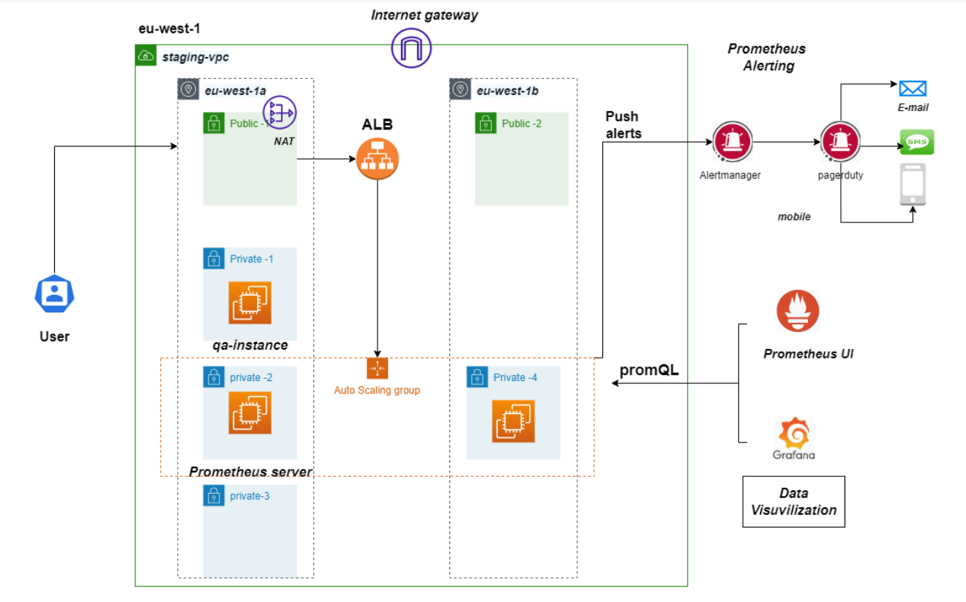

**Prerequisites**

Terraform installed on your local machine.

AWS CLI configured with appropriate credentials and region.

Basic knowledge of AWS services like VPC, EC2, ALB, Auto Scaling, and Prometheus.

**Steps to Create the Architecture**

1. Create a VPC with public and private subnets.
2. Set Up Internet Gateway and NAT Gateway
3. Launch EC2 instances in the private subnets.
4. Setup an Application Load Balancer (ALB) to distribute traffic.
5. Configure Auto Scaling Group for the application instances.
6. Deploy Prometheus and Alertmanager in a private subnet.
7. Setup Prometheus UI and Grafana for data visualization.
8. Configure alerting via Alertmanager to various notification channels.

**1.Create a VPC with public and private subnets.**

Create AWS Provider

You need to add AWS Provider to be able to create AWS resources. Create a terraform file named “main.tf” in the root of a directory you want to use.

To download necessary plugins, configuration, etc., you should call

terraform init

* VPC (staging-vpc) in the eu-west-1 region.
* Two public subnets (Public-1 in eu-west-1a and Public-2 in eu-west-1b).
* Four private subnets (Private-1, Private-2, Private-3, Private-4).

**2. Set Up Internet Gateway and NAT Gateway:**

* Attach an Internet Gateway to the VPC.
* Create a NAT Gateway in one of the public subnets ( Public-1).
* Update the route tables for the public subnets to route internet traffic to the Internet Gateway.
* Update the route tables for the private subnets to route internet traffic to the NAT Gateway.

**3.** **Launch EC2 instances in the private subnets.**

**QA Instance:**

* Launch an EC2 instance (qa-instance) in Private-1.
* Ensure it has the necessary security groups to allow access from the ALB and SSH access from a management IP.

**Prometheus Server:**

* Launch an EC2 instance for the Prometheus server in Private-3.
* Install and configure Prometheus on this instance.

**4.Setup an Application Load Balancer (ALB) to distribute traffic.**

* Create an ALB and place it in the public subnets (Public-1 and Public-2).
* Configure listeners and target groups to forward traffic to the instances in the Auto Scaling group.

**5.Configure Auto Scaling Group for the application instances.**

* Create an Auto Scaling group and associate it with the ALB.
* Launch EC2 instances in Private-2 and Private-4 as part of the Auto Scaling group.

**6** .**Deploy Prometheus and Alertmanager in a private subnet.**

* Configure Prometheus to scrape metrics from the relevant instances and applications.
* Set up PromQL queries for data visualization and alerts.

**7.Setup Prometheus UI and Grafana for data visualization.**

* Configure Alertmanager in Prometheus to handle alerts.
* Set up alerting rules in Prometheus.
* Configure Alertmanager to send notifications to PagerDuty, email, and SMS.

**8.Configure alerting via Alertmanager to various notification channels.**

Use Terraform's local_file resource to create configuration files for Alertmanager.

NOTE:

Terraform commands to run

Terraform init – to initialize

Terraform plan – showing what actions can perform

Terraform apply –auto-approve – it run the code and creates the infrastructure